Syeda Reeha Quasar

14114802719

3C7

Experiment - 8

Switching Theory and Logic Design (STLD)

Aim

To realize 2 bit Magnitude Comparator.

# **EXPERIMENT - 8**

## **AIM:**

To realize 2 bit Magnitude Comparator.

## **Hardware and Software Apparatus Required**

Hardware:

Breadboard, IC 7400 (NAND), IC 7410 (3 input NAND), IC 7404(NOT), LEDs, 5V power supply, connecting wires.

Software Simulation:

The schematic models of the desired circuits will be stimulated on MULTISIM (Free Software), easily accessible at [www.multisim.com](http://www.multisim.com).

Components used – Source (Clock Voltage), Passive elements (resistor), Digital components (AND, OR, NAND, NOR, XOR, XNOR, Inverter), Probe for Analysis and annotation (Digital), Schematic connectors (Ground)

## **Theory:**

Magnitude Comparator is a logical circuit, which compares two signals A and B and generates three logical outputs, whether A > B, A = B, or A < B. The outcome of comparison is specified by three binary variables that indicate whether A>B, A=B, or A<B. 2-Bit Magnitude Comparator Compares two numbers each having two bits (A1, A0 & B1, B0).

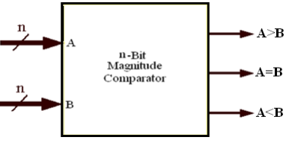

Fig 11.1 Block Diagram Of comparator

**Designing of 2 bit comparator**

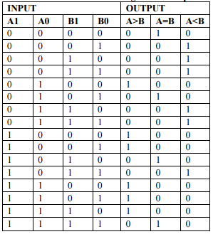

K-Map is used to minimize Boolean function obtained from truth table as shown below

a) **FOR A>B FOR A=B**

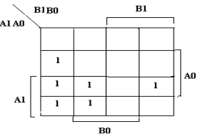 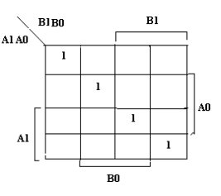

**FOR A<B**

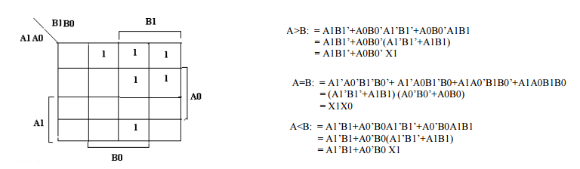

b)

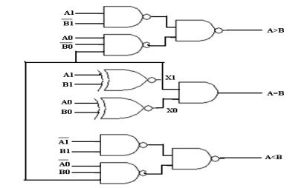

Fig 11.2 a)K Map minimization b) logic Diagram of comparator

From the above K-maps logical expressions for each output can be expressed as follows:

A>B:A1B1’ + A0B1’B0’ + A1A0B0’

A=B: A1’A0’B1’B0’ + A1’A0B1’B0 + A1A0B1B0 + A1A0’B1B0’

: A1’B1’ (A0’B0’ + A0B0) + A1B1 (A0B0 + A0’B0’)

: (A0B0 + A0’B0’) (A1B1 + A1’B1’)

: (A0 Ex-Nor B0) (A1 Ex-Nor B1)

A<B:A1’B1 + A0’B1B0 + A1’A0’B0

## **Procedure:**

1. Check all the components for their working.
2. Insert the appropriate IC into the IC base.
3. Make connections as shown in the circuit diagram.
4. Verify the results and observe the outputs.

## **PRECAUTIONS:**

1. All ICs should be checked before starting the experiment.
2. All the connection should be tight.
3. Always connect ground first and then the supply.
4. Switch off the power supply after completion of the experiment.

## **RESULT:**

2 bit magnitude comparator has been studied and its truth table is verified.

**Circuits and Output waveform for 1 bit magnitude comparator.**

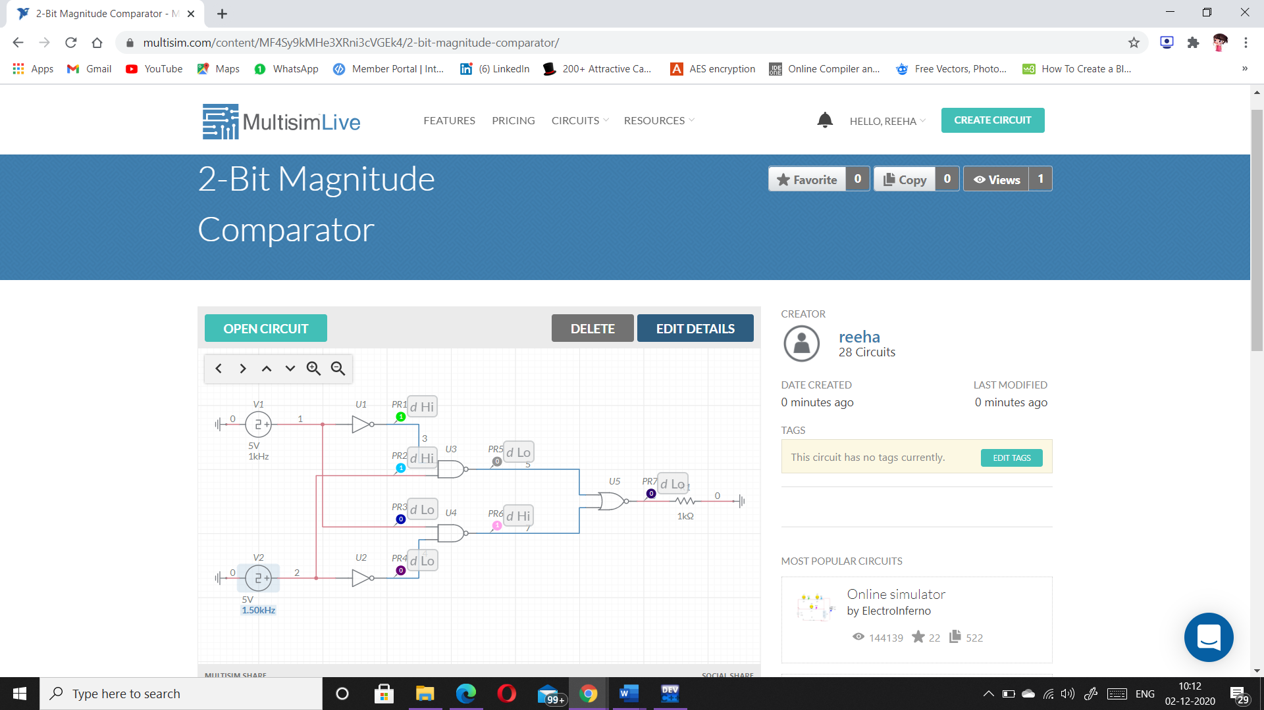

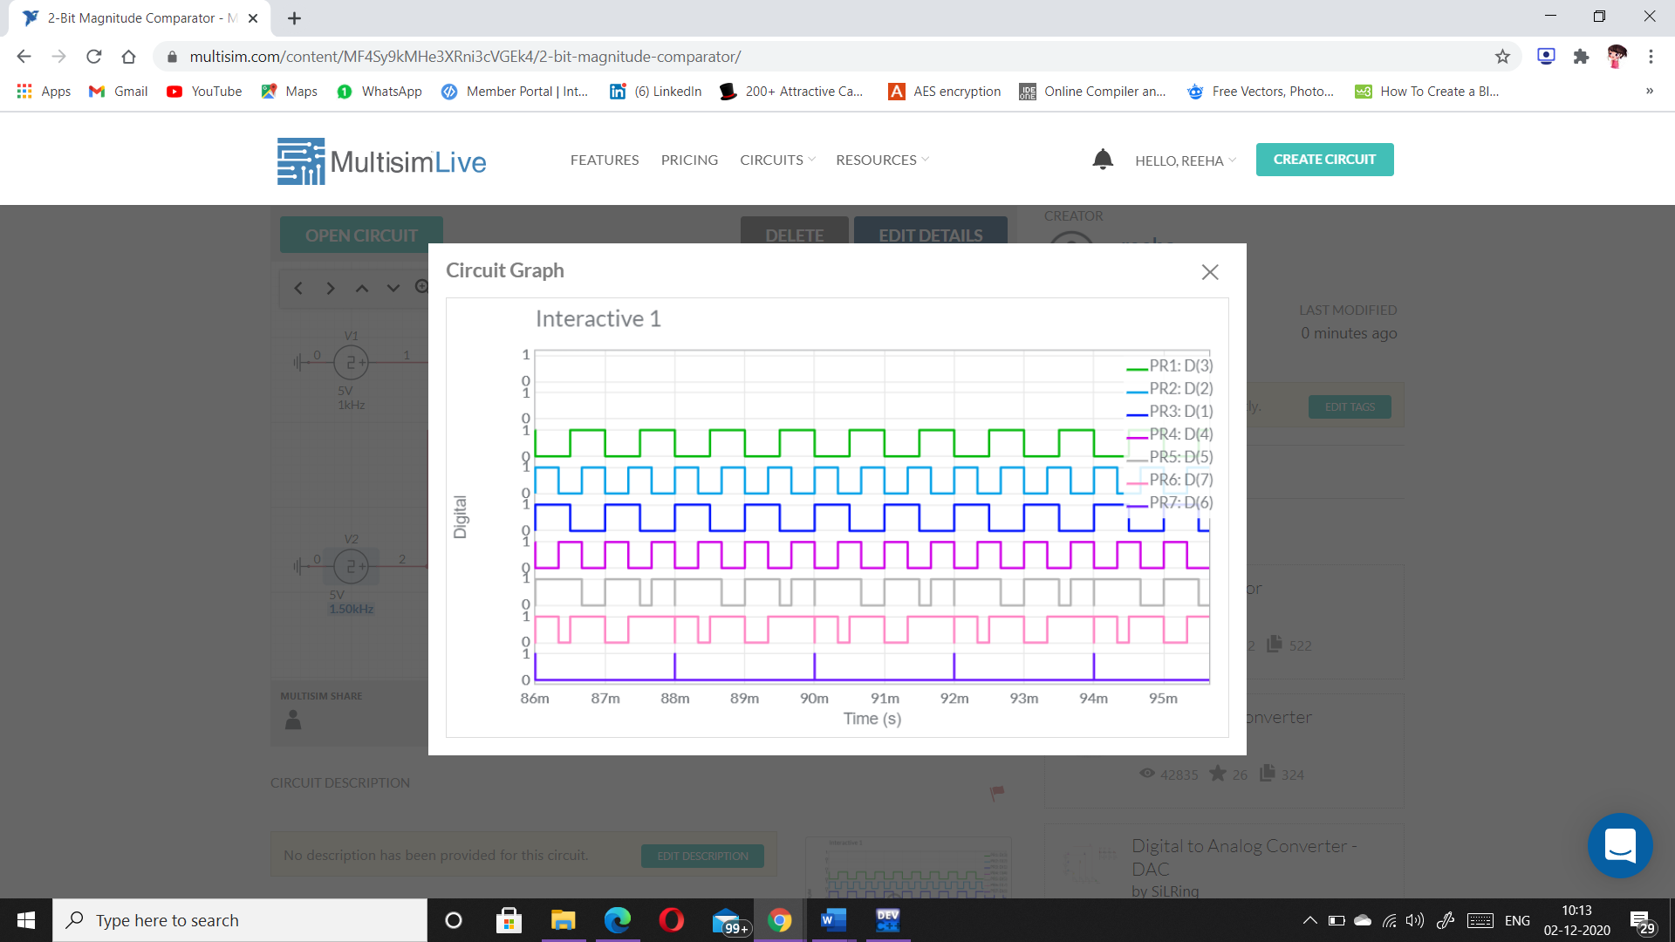

**Circuits and Output waveform for 2 - bit magnitude comparator:**

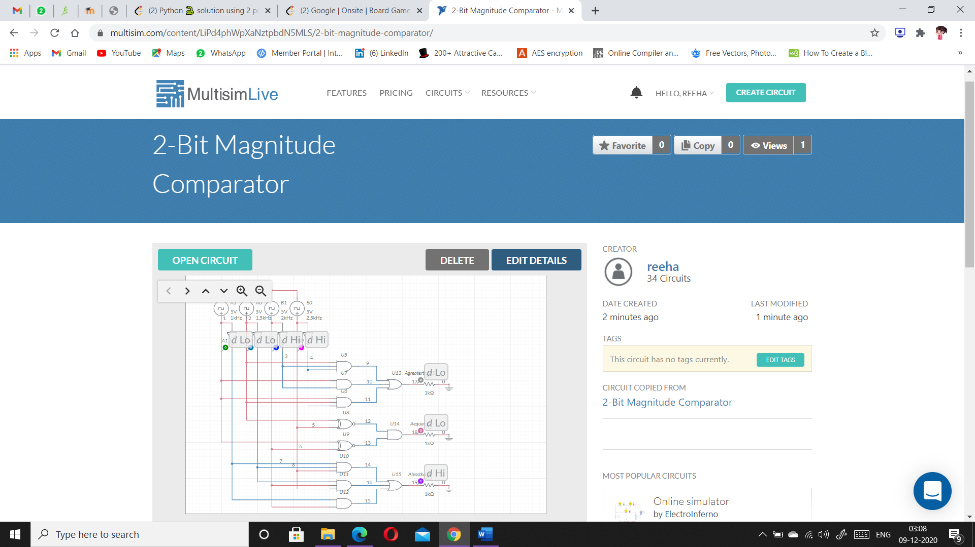 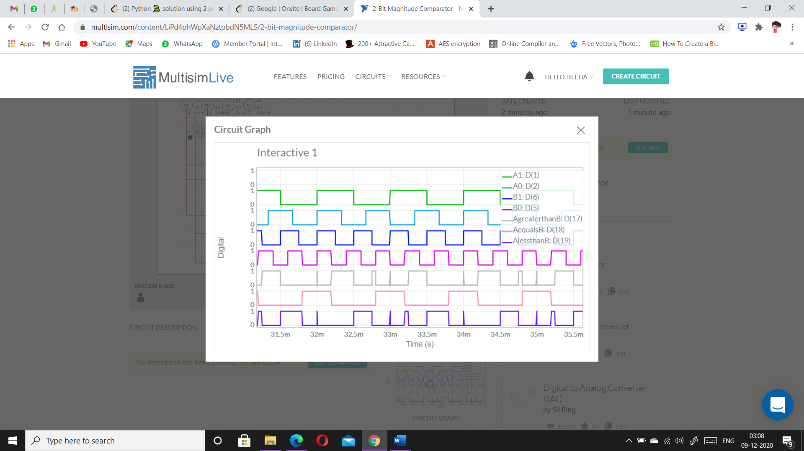

# **VIVA-VOCE QUESTIONS:**

1. **Write down expressions for 4-bit magnitude comparator.**

Ans.

* If A3 = 1 and B3 = 0, then A is greater than B (A>B). Or
* If A3 and B3 are equal, and if A2 = 1 and B2 = 0, then A > B. Or
* If A3 and B3 are equal & A2 and B2 are equal, and if A1 = 1, and B1 = 0, then A>B. Or
* If A3 and B3 are equal, A2 and B2 are equal and A1 and B1 are equal, and if A0 = 1 and B0 = 0, then A > B.

From the above statements, the output A > B logic expression can be written as

[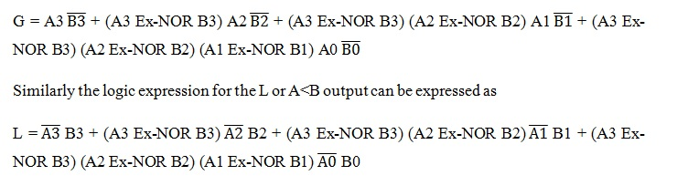](https://www.electronicshub.org/wp-content/uploads/2015/07/exp3.jpg)The equal output is produced when all the individual bits of one number are exactly coincides with corresponding bits of another number. Then the logical expression for A=B output can be written as

E = (A3 Ex-NOR B3) (A2 Ex-NOR B2) (A1 Ex-NOR B1) (A0 Ex-NOR B0)

1. **What are applications of magnitude comparator?**

Ans.

Digital comparator and magnitude comparator is used in different applications where data comparison is mostly required in many of the activities, and these hold many benefits too.

* Now, look into few of the applications of comparators
* Used for authorization purposes (such as password management) and [biometric](https://www.elprocus.com/biometric-authentication-system-applications/) applications.
* These are implemented in process controllers and also in [servo motor](https://www.elprocus.com/servo-motor-interfacing-with-8051-microcontroller/) controls.
* Implemented for the data comparison of variables like temperature, the pressure is compared with that of reference values.
* Used to address decoding circuitry in computers.

Thus, this is all about digital [comparator](https://en.wikipedia.org/wiki/Comparator) and magnitude comparator. So, the augmented performance of comparators allowed these devices to gain more prominence in the electronics industry and let them be implemented in many applications.

1. **What are Magnitude comparators?**

Ans.

A magnitude digital Comparator is a combinational circuit that compares two digital or binary numbers in order to find out whether one binary number is equal, less than or greater than the other binary number. We logically design a circuit for which we will have two inputs one for A and other for B and have three output terminals, one for A > B condition, one for A = B condition and one for A < B condition.

